Chapter 1, Solution 21

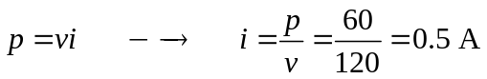
q = it = 0.5x24x60x60 = 43.2 kC

